# Maths square puzzle 1

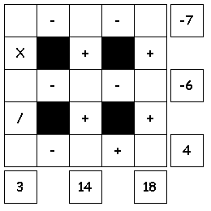  
  
Try to fill in the missing numbers.

Use the numbers 1 through 9 to complete the equations.

Each number is only used once.  
Each row is a math equation. Work from left to right.  
Each column is a math equation. Work from top to bottom.

# Maths square puzzle 1 Solution

